# My Profile

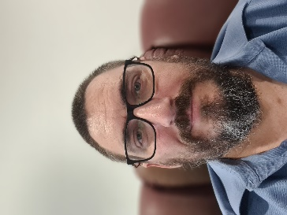**Name:** Craig Scofield

**Student Number:** S3971733

**Student email address:** [s3971733@student.rmit.edu.au](mailto:s3971733@student.rmit.edu.au)

**GitHub URL:** <https://github.com/AuzzDad/IITA1>

**GitHub Pages URL:** <https://auzzdad.github.io/IITA1/index.html>

**Personal Information:**

I have grown up living across the eastern coastline of Australia. My dad was in the Army, so we moved every couple of years. So, as you can imagine, I went to about ten different schools growing up.

I have spent most of my life living a quiet life where my parents prevented me from playing many physical sports and activities. The protectiveness was due to me being born with a congenital bone deformity in my left leg. When I was born, my left leg was approximately 3 inches shorter than my right leg. I spent the next 13 years of my life in and out of hospitals, having multiple operations to try and make my legs the same length. Only now, my left leg is longer than my right leg. Ha-ha

Growing up with this disability has forced me to rethink how to do things other people do without thinking. For example, I had to give up dreams of being like my dad in the military or participating in any sport. So, I read a lot, did a lot of puzzles and jigsaws, and later enjoyed computer games and consoles.

I now am married to a beautiful wife and have two wonderful kids… sorry teenagers. I now relax and enjoy life sitting down, developing artistic expression in building Lego creations or as simple as playing the Xbox.

**Interest in IT**

I first became fascinated by computers when I was a young teenager. I pulled apart the family computer working out how it all worked, then putting it back together. I was hooked. As soon as I had the money, I started buying parts to build my first computer. I scoured the libraries for anything to do with computers and read read read.

With my disability, I knew this was something I could do, sit down. I was fortunate enough to be in Canberra when leaving school and getting a government job that exposed me further to IT.

With that knowledge, I started a computer company serving families, and small businesses for IT needs. The company was steadily growing, and I loved every minute of it.

Unfortunately, I made a rookie error and decided to travel overseas with my brother without putting too much thought into my clients. And when I returned, my client base had gone elsewhere.

Since then, I have had various IT jobs ranging from maintaining IT equipment for small firms to supporting mine sites and processing plants.

I decided to formalise my knowledge and fill in any gaps I know by studying Bachelor of Information Technology. But the requisites require me to complete this course (Introduction of Information Technology) and Introduction to Programming.

My body has reinforced the idea that I must find a more back seat position. Gone are the days when I could physically work out in the field fixing up computer equipment.

I aim to complete this Bachelor's course and possibly focus on Cyber Security.

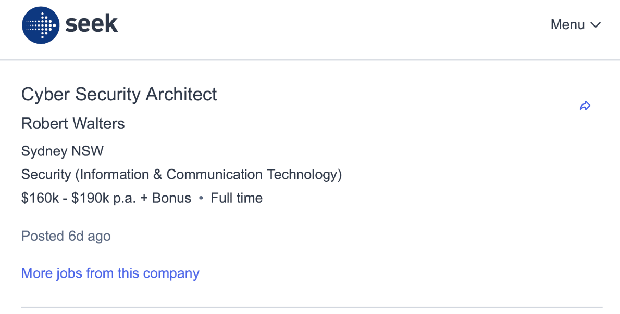**Ideal Job**

<https://www.seek.com.au/job/58335405?type=standard#sol=516b6c31e7971bd98537a18d4e96cffe8bb3ecf8>

**Cyber Security Architect**

This position will oversee identifying and securing the security of the IT architecture within the business. Maintaining the protection and negating any security risks will be your job. You will also be part of the procurement and selection of various Vendors to assist in the protection required.

The requirements for this position that an applicant must meet for this job entail the following:

* High technical knowledge in relevant business applications, architecture, services, and security practices
* A high grasp of security practices, protocols, standards, and infrastructures.
* Relevant certifications
* 5+ years of experience in Security risk and infrastructure design.

My recent experience and qualifications are as below:

* 25 years in the IT industry – little to no security protocol, application, or cloud experience
* A firm grasp of Microsoft office products and essential Server operating systems experience.
* A simple understanding of security concepts and protection

My plan to be qualified for this job will start with completing a Bachelor of IT, gaining employment somewhere in the security field, and learning specific certifications that will eventually lead me to SABSA, ISSAP, CISM, SANS, and CISSP qualifications.

**Personal Profile**

1. **Myers-Briggs Test -** [**www.16personalities.com**](http://www.16personalities.com) **-** [**Link to Profile**](https://rmiteduau-my.sharepoint.com/personal/s3971733_student_rmit_edu_au/Documents/University/Assignments/Myers-Briggs%20Profile.pdf)

* The results from the Myers-Briggs test surprised me.
* I couldn't believe the answers were accurate by answering the questions honestly. It was eye-opening to see it explaining the reasoning behind my way of thinking.
* The results will help shape and direct how I am a productive team member, as it highlights the areas in that I would excel.
* With this knowledge, I would be good at building a team with a broad spectrum of people.

1. **Learning Style Test -** [**http://www.educationplanner.org/students/self-assessments/learning-styles-quiz.shtml**](http://www.educationplanner.org/students/self-assessments/learning-styles-quiz.shtml) **-** [**Link to Profile**](https://rmiteduau-my.sharepoint.com/personal/s3971733_student_rmit_edu_au/Documents/University/Assignments/Learning%20Style%20Profile.pdf)

* This test reinforces that I am a visual learner. In a team environment, having this trait will help me assist the team in speaking in visual terms. It would be beneficial to have this knowledge beforehand when forming the team, as we will better understand how to express our thoughts and ideas.

1. **Psychometric Test -** [**https://www.psychometricinstitute.com.au/test-area-instructions.asp?testid=18**](https://www.psychometricinstitute.com.au/test-area-instructions.asp?testid=18) **–** [**Link to Profile**](https://rmiteduau-my.sharepoint.com/personal/s3971733_student_rmit_edu_au/Documents/University/Assignments/Personality%20Test%20Profile.pdf)

* This Psychometric test is another example where the insight was accurate. This test will probably help me not to be so self-focused on my achievements but more on Team results. Having foreknowledge of this in others would allow us to make a more effective and coagulant team.

**IT Project - Wireless K/V/M Kits**

**Overview:**

A device with a wireless keyboard, Mouse, and up to 2 Monitors plugged into it; that will communicate wirelessly to multiple computers with the secondary devices plugged into a USB port. This device will also have empty USB ports that can be discovered and read from remote machines.

The currently active computer will change by pressing one of 8 buttons across the front. To identify which computer is active is observed by the illuminated number.

Choosing how many computers are connected depends on the number of secondary devices plugged in.

**Motivation:**

The motivation behind Wireless KVMs comes from multiple situations where normal KVMs are in use. The workspace is limited and restrictive due to the mess of cables from the KVM.

This wireless KVM allows more computers to be accessed that requires only power and reduces the area needed to be set aside for this job.

It is advantageous where the area to work is not large, and only setting up a few machines at a time will cause delays.

**Description:**

The Wireless KVM, commonly known as Keyboard, Video, Mouse, will utilise the 5GHz bandwidth to communicate between the primary and secondary devices.

The Primary Device will have the following ports:

* 2 x HDMI
* 2 x DisplayPorts
* 2 x USB 3 Ports

The Secondary Device will be a USB 2 device.

The Primary device will be large enough to have eight numbers across the front that illuminate when they are active. However, it will not be too large as the device's size will depend on the circuitry to switch on and off the chipsets.

The wireless KVM can come in multiple sizes. 5-8 capability is an excellent range to have. However, the capability of the chipsets could restrict this. This capacity is dependent on the bandwidth and frequency of the chipsets. Reducing the screen lag and improving latency, the bandwidth must be capable of transmitting the required data when switching to another computer.

**Tools and Technologies:**

The hardware required consists of a standard Keyboard, Mouse and Monitors. The Primary Device comprises the necessary chipset to encode and decode the signals transmitted to and from the Secondary Device. There will be physical illuminated numbers on the front of the Primary Device. The software should be similar to the existing KVMs, except for transmitting data across Bluetooth.

**Skills Required:**

The skills required to facilitate this IT Project will combine a firm understanding of communications across the 2.4GHz spectrum, Bluetooth protocols, and the appropriate programming language.

The hardware required for this IT Project will be circuitry, PCB Boards, and chipsets like the Semtech AVP1000, capable of transmitting the required bandwidth.

**Outcome:**

If this IT Project comes to fruition, the IT industry will benefit greatly, especially if we can keep the costs to a reasonable value. Large corporations, Government Agencies, medium size computer companies, and IT Retail shops could utilise the Wireless KVM device to clear up prime real estate regarding workspaces available.

It will also benefit teams that maintain multiple servers within their organisations, as they have just eliminated 75% of their workspace requirements.